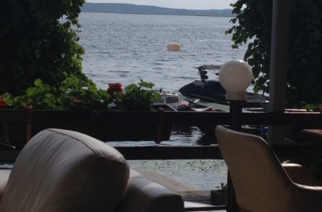
Baltic Senior Championships Afterparty
Summer café/restaurant “Terase” by the lake Ķīšezers
11 Roberta Feldmaņa street, Riga
13.06.2015 starting at 20.00 till sunrise
Things we’ll enjoy at the event:
- Cosy rooms with a summer terrace (in case of rain – an enclosed terrace) and walks by the lake Ķīšezers
- Good music, the opportunity to dance until the morning light
- A delicious hot dinner
- A buffet
- To stay alert or before going home – a cup of coffee and a piece of cake
- And a glass of wine, cider or beer (your choice) on your arrival
During the event alcoholic beverages at the café will have very friendly prices.
1. Good vodka – 50 cl – EUR 1
2. Whiskey "Jameson" – 50 cl – EUR 2
3. A glass of good wine – 150 cl – EUR 2.50
4. A variety of interesting cocktails – from EUR 3
Thanks to the friendly prices offered by the café we think that it won’t be necessary to bring your own beverages.

Things we can expect at the event:
- Honouring and awarding the 2015 Baltic senior champion and the 2nd and 3rd place winners
- Cheerful conversations, the enjoyment of reunions and lots of dancing
- You will have the opportunity to participate in the first international Baltic badminton player’s poker game:
1. Each country delegates 2 players for the poker game
2. Form of poker is Texas Hold’em
3. Players will be playing with chips worth 7 EUR (chips are provided by the event organizers)
4. Game lasts 30 minutes, after which the dealer counts each player’s chips and announces the winner’s country
5. Chips can be exchanged for a drink of your choice at the café’s bar
- The opportunity to play poker:
- Chips can be purchased at the café’s bar
- Chips can be exchanged for a drink of your choice at the café’s bar

To allow us to enjoy the atmosphere of the evening a participation fee of 23 EUR is required.
See you at the lake Ķīšezers!

